CURRICULUMN VITAE

MAI HONG QUY |  |  | 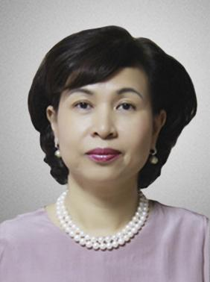
 | Rector of HCM University of Law
 | HCM University of Law, No. 02 Nguyen Tat Thanh, Ward 12, District 4, Ho Chi Minh City
 | mhquy@hcmulaw.edu.vn; mhquy@yahoo.com
 | Civil law; International judicial law
 | Vietnamese, English , Russian, French
Education
Qualifications |  | - Doctor of Civil Law - International Justice  - Bachelor of Laws
Major(s) |  | - Civil law  - International justice
University(s) |  | Moscow National University, Lomonoxop - Soviet
Work history
4/1991 - 7/1991 |  | Lecturer, Faculty of Philosophy - Law, Ho Chi Minh City University
1991 - 1995 |  | Head of Law Department, School of External Economics, National University of External Economics
3/1995 - 3/1996 |  | Dean of Faculty of Law, HCMC University
2002 - present |  | Arbitrator, Vietnam International Arbitration Centre at Vietnam Chamber of Commerce and Industry (VIAC)
3/1996 – 6/ 2006 |  | Member of the Party Committee - Vice Rector of HCM University of Law
6/2006 - 1/2008 |  | Deputy Secretary of Party Committee - Principal, HCM University of Law
1/2008 - present |  | Secretary of the Party Committee (term 2011 - 2016) - Rector of HCM University of Law
Membership
2009 - 2014 |  | Member of the Titles Council of Professors / Interdisciplinary Professors
2015 - 2020 |  | Vice President, Titles Council of Professors / Interdisciplinary Professors
1/2008 - present |  | Standing Committee of Party Committee of Universities - Colleges and Professional College of Ho Chi Minh City (term of 2011 - 2016).
 |  | Arbitrator, VIAC
Qualifications / certificates / outstanding achievements
2010 - 2015 |  | Various textbooks, reference books and monographs published
1999 - 2006 |  | Chairman of many good scientific research projects
1989 - 2016 |  | Various scientific articles published by the Journal of Legal Science, Journal of Legislative Research, State and Law, etc.
2001 - 2002 |  | High-class political theory training course of Ho Chi Minh City National Political Academy

